Fixing Boost footprint & layout
I didn’t' finish the boost layout for critical design review. One big issue was that the pads weren't connecting when drawing traces (keyboard shortcut X) .
ok to fix this i re downloaded the data sheet, schem and footprint for the TPS61288RQQR from digikey .
I also had downloaded the TPS6122LRQQR which only differs by L RQQR . this version has better heat dissipation/ratings but it was out of stock and not the part lam had used in we bench so we are using RQQR. They have the same datasheet.
I tried putting in the L RQQR footprint just to see if this variant was different (maybe we should use it instead)
The dimensions and pads were the same BUT the pads actually connected to the traces.
Why would the footprints be the same dimensions but they behave differently?
I remembered ERC errors were something along the lines of "undefined is connected to power" or "output is connected to power" for all the pins on the boost so I opened both components in the schematic editor to investigate. (technically can't open both at once so one is a screen shot)
(note : schematc editor from the main menu of kicad changes schematic for the library so for all parts. so go to schematic editor then select component to edit.
in contrast if you click on the component in the schematic and then "edit schematic" you only edit that component not all components of that type. both are useful. I edit the master schematic since the issues seem like the schematic i downloaded was incomplete & should be fixed for all)
results & explanation below.
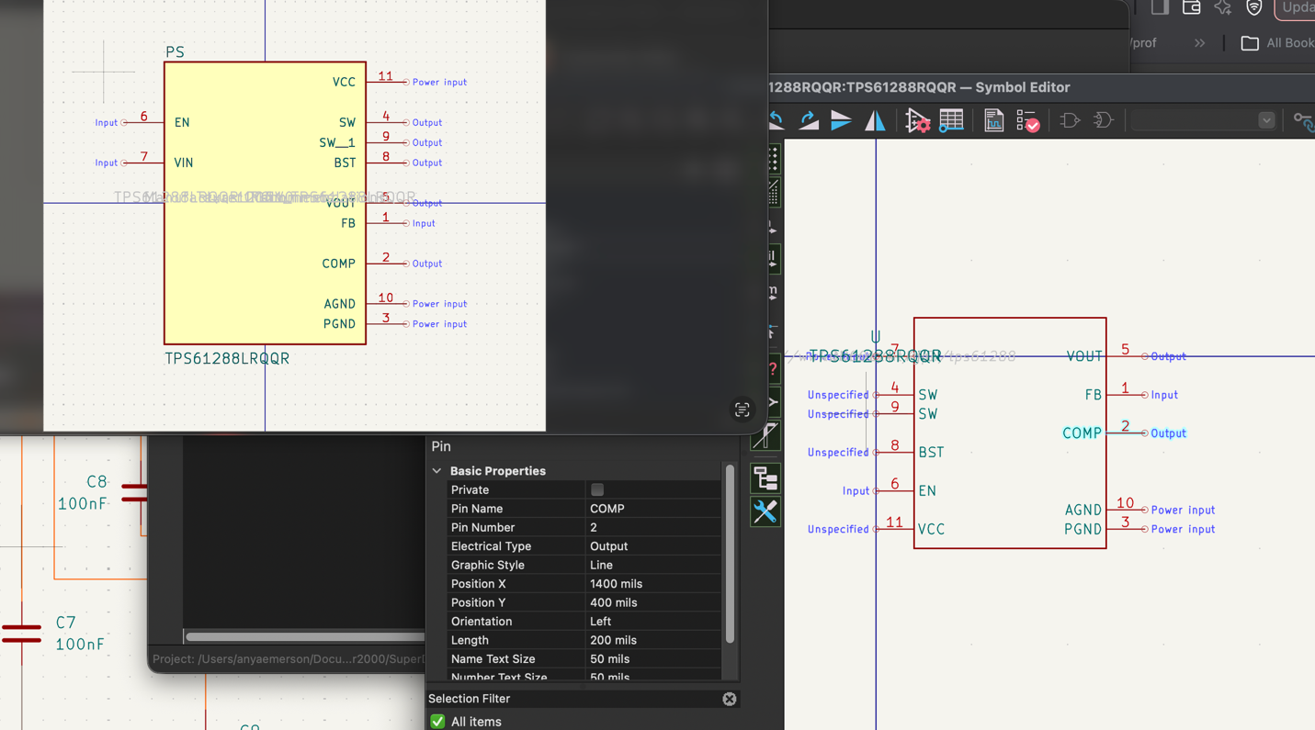
^^ explanation: Left is L RQQR, right is RQQR, the part we are using
The RQQR did not have the pins defined, this explains the ERC errors I was getting
Manually chagned RQQR pins to match the L RQQR version (same data sheet the pins should be the same type)

Now fixing the footprint.
I compared the RQQR and L RQQR in the footprint editor (same as schematic: used main menu of kicad to edit master/all footprints for a particular component)
the L footprint does connect all pads. The non L version we had for the desgn review did not so thats why connections weren't working.
The footprint for L and non L were different:
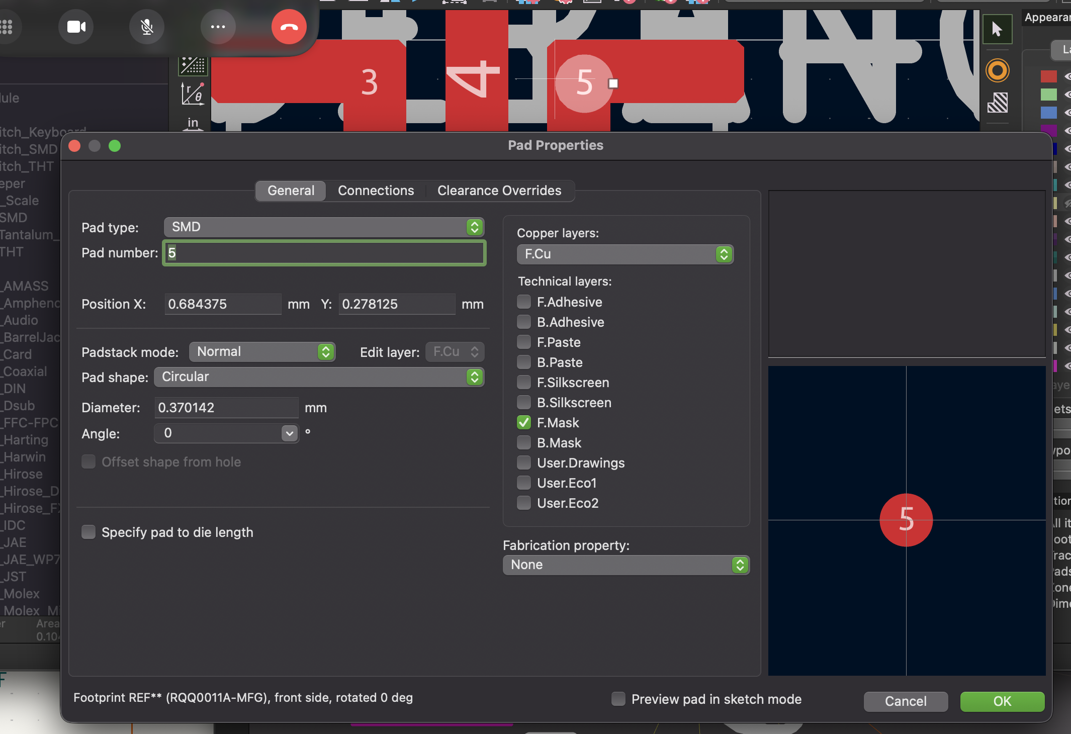
^^ explanation: this is the pad propertes for the RQQR, (the componet we are using) the pad is just the circle, sittng on top of a polygon shape.
In comparison for the L RQQR, the pad was the entire shape the 5 was on, the weren't 2 separate things.
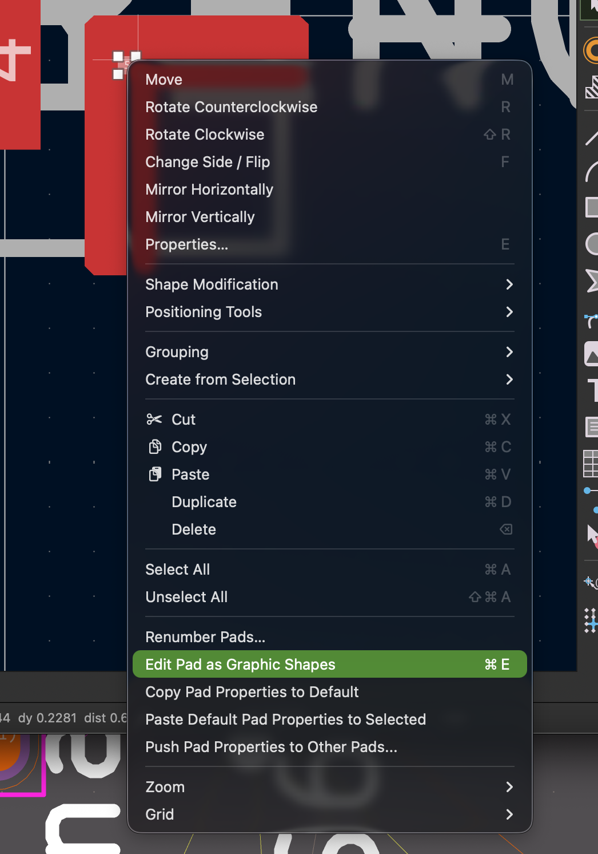
^^To fix the pad, rightclick on the pad(circle), right click and "edt pad as graphc shapes" or command E (i think contorl E on windows)
Then click the polygon that should be merged with the pad, the hit cmdE again to get out of graphic shpae edit mode. The top left should have a message that says somethng simlar.
after this is done the entire shape should be the pad!

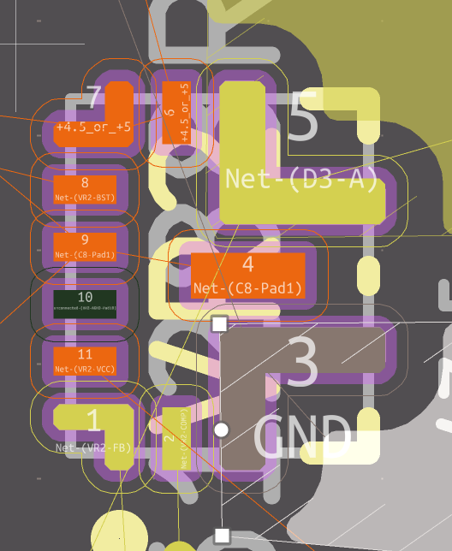
^^ resutlts: now update footprint from schematic and the pads are now colored (becuase I defined nets) . Previously the pads were red (defualt no connection) . Now I can actually connect traces to the pad!

LAYOUT
ok now to fixng the layout, week6 i hadn't done the layout as defnened in TPS's datasheet.
Issues:

1. no vias below the component. I had already tried findng other footrints on other sites but none had vias already.
I can't add vias under the component, DRC violation, kicad wouldn't let me. ALSO vias that i have defined ( 0.7 / 0.3 mm) are way bigger than what s in the datasheet. I set this size based on what JLPCB defined as minimum size that can be manufactured. Theres a chance I defined this wrong but thats a question for when we review it again with TA/course instr.

2. Cap & R are much bigger than the ones in the datasheet. no way around this we need to use 0805 or 0603 to be able to hand solder
3. Ground vs AGND. in webench both GND and AGND are connected from the boost. Do these both go to GND on my board?
AGND is a whole other issue I get to later but for this I just created a GND area/plane.

not much to document here, this took awhile but i just I followed the datasheet as best I could , screenshot of intermediate results.
I end up changing components ( esp. inductor ) and footprints so this is just showng I added vias & the boost can connect to traces.
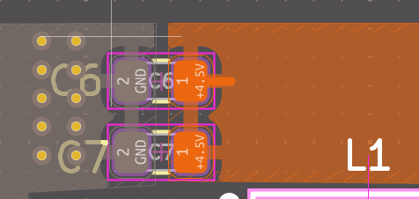
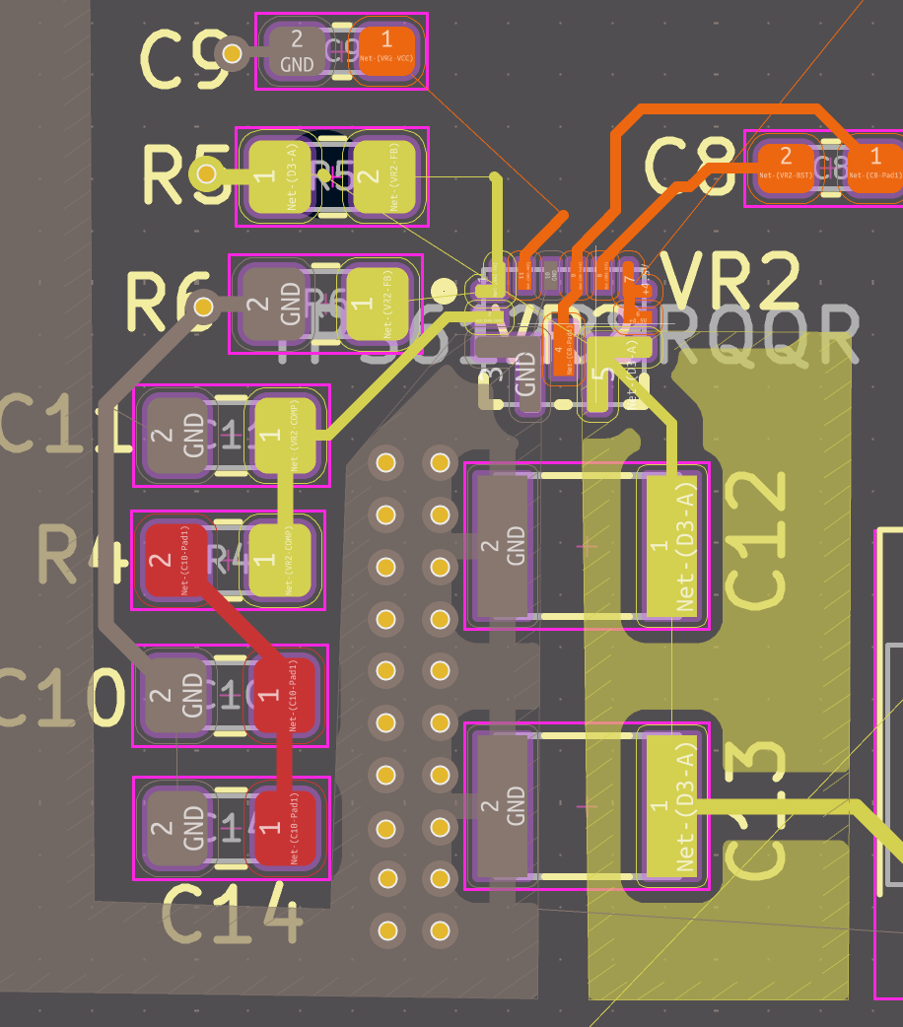
datashet
